[**HOW TO INSTALL VPN ON WINDOWS SERVER 2012 R2**](http://www.thomasmaurer.ch/2014/01/how-to-install-vpn-on-windows-server-2012-r2/)

This post shows you how you can install a VPN Server on Windows Server 2012 R2 Step-by-Step.

First install the “**Remote Access**” via Server Manager or Windows PowerShell.

[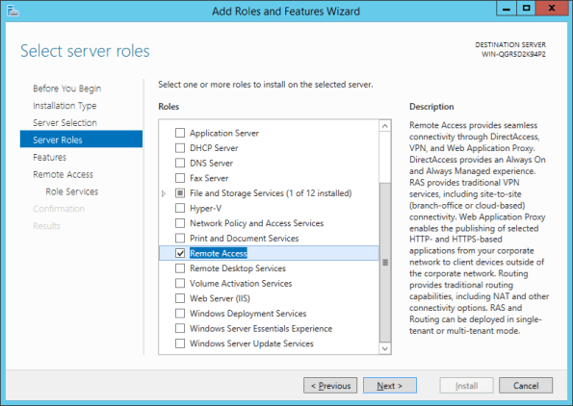](https://i1.wp.com/www.thomasmaurer.ch/wp-content/uploads/2014/01/Remote-Access.png)

Select the “**DirectAccess and VPN (RAS)”** role services.

[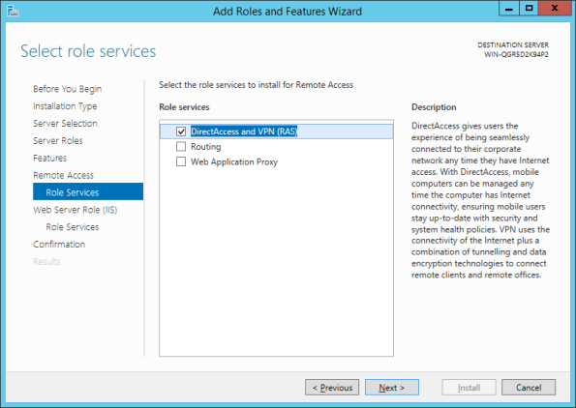](https://i2.wp.com/www.thomasmaurer.ch/wp-content/uploads/2014/01/DirectAccess-and-VPN-RAS.png)

On the next steps just use the default settings. After that you can have a look at the Overview screen and install the role.

[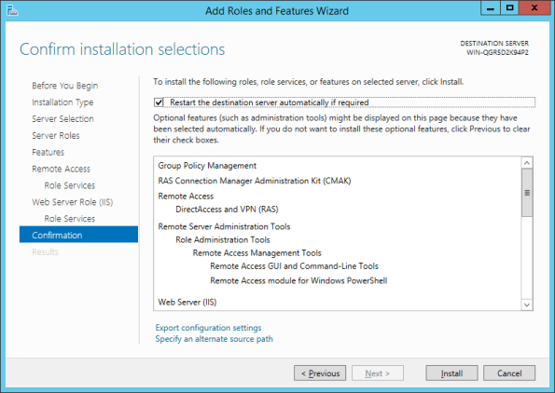](https://i0.wp.com/www.thomasmaurer.ch/wp-content/uploads/2014/01/Remote-Access-Installtion-Confirmation.png)

After the features are installed, which can take a while to finish you see the link for the Getting Started Wizard. Click on “**Open the Getting Started Wizard**“.

[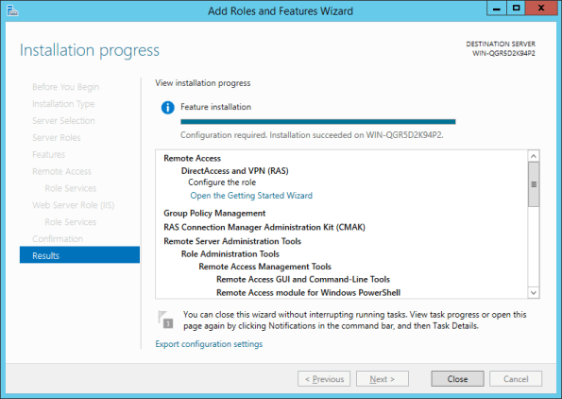](https://i1.wp.com/www.thomasmaurer.ch/wp-content/uploads/2014/01/Getting-Started-Wizard.png)

This opens a new wizard which will help you to configure the server. On the first screen select “**Deploy VPN only**“.

[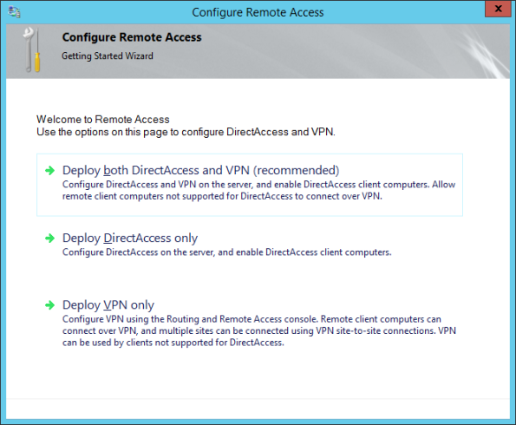](https://i0.wp.com/www.thomasmaurer.ch/wp-content/uploads/2014/01/Deploy-VPN.png)

This opens the Routing and Remote Access MMC

[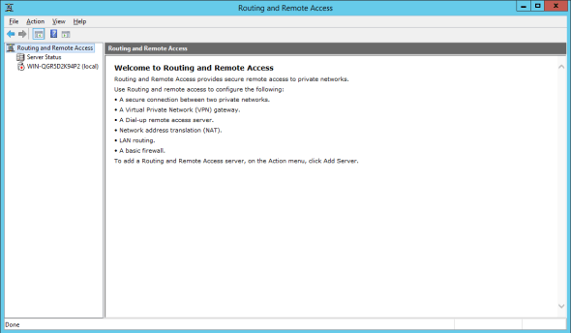](https://i2.wp.com/www.thomasmaurer.ch/wp-content/uploads/2014/01/Routing-and-Remote-Access-MMC.png)

Right click on the Server name and click on “**Configure and Enable Routing and Remote Access**“.

[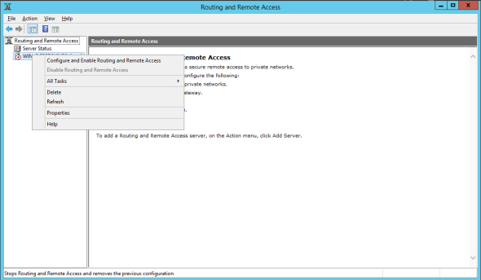](https://i2.wp.com/www.thomasmaurer.ch/wp-content/uploads/2014/01/Configure-and-Enable-Routing-and-Remote-Access.png)

On the new wizard select “**Custom configuration**“.

[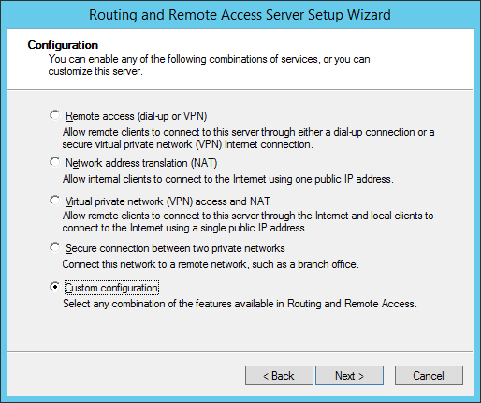](https://i1.wp.com/www.thomasmaurer.ch/wp-content/uploads/2014/01/Custom-VPN-Configuration.png)

Select “**VPN Access**“.

[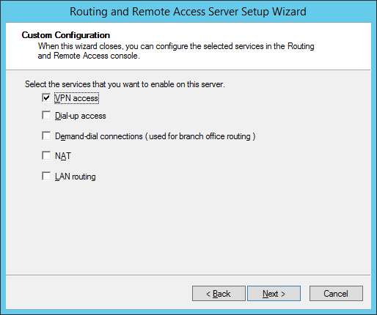](https://i2.wp.com/www.thomasmaurer.ch/wp-content/uploads/2014/01/VPN-Access.png)

After you have click finish you can now start the Routing and Remote Access service.

[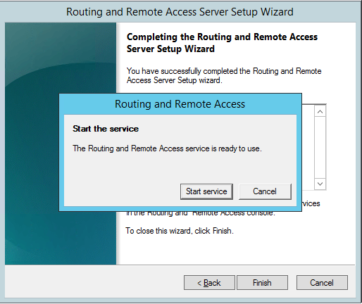](https://i1.wp.com/www.thomasmaurer.ch/wp-content/uploads/2014/01/Start-Rotuing-adn-Remote-Access-Service.png)

If you have an other firewall between the internet and your Windows Server you have to open the following Firewall port sand forward them to your Windows Server:

For PPTP: 1723 TCP and Protocol 47 GRE (also known as PPTP Pass-through)  
For L2TP over IPSEC: 1701 TCP and 500 UDP  
For SSTP: 443 TCP

[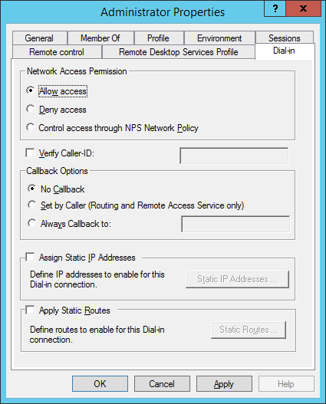](https://i1.wp.com/www.thomasmaurer.ch/wp-content/uploads/2014/01/Allow-Remote-VPN-Access-for-User.png)

If you don’t have a DHCP Server in your environment you have to add a static IP address pool. This is often needed if you have a single server hosted at a service provider. In the properties of your VPN server you can click on the IPv4 tab and enable and configure the “Static address pool”.

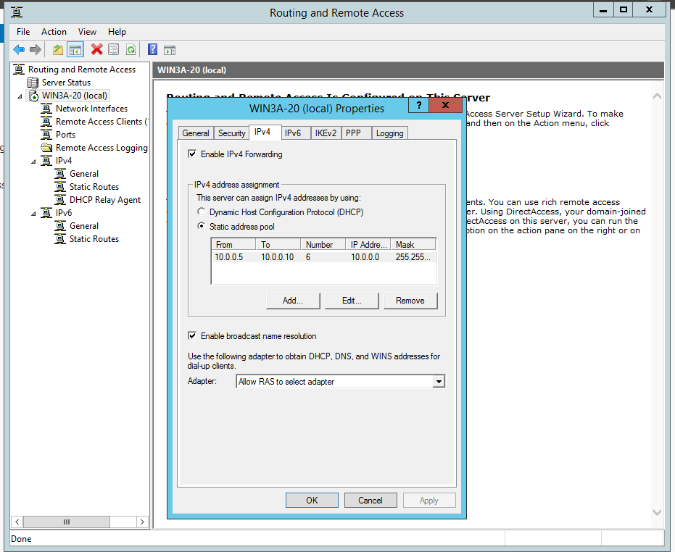

You now have to add a IP address from the same subnet as your static address pool to the network interface of your server, so users can access the server.

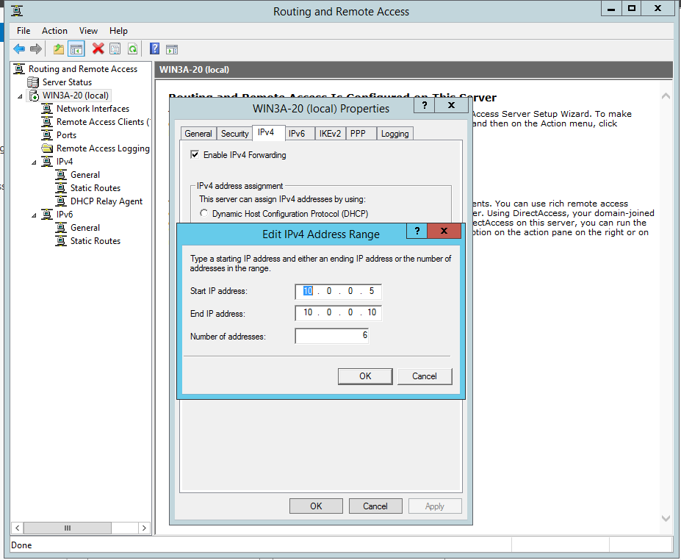

Now we to create VPN users on the server, lets create an OU called VNP_Lab and an other OU called Users that is nested under the VPN_Lab OU via powerShell.

New-ADOrganizationalUnit -Name "VPN_LAB"

By default, PowerShell will create the OU off of the domain root. You can use PowerShell to get the newly created OU.

Get-ADOrganizationalUnit -Identity "OU=VPN_LAB Users,DC=abdel-lab2,DC=Local"

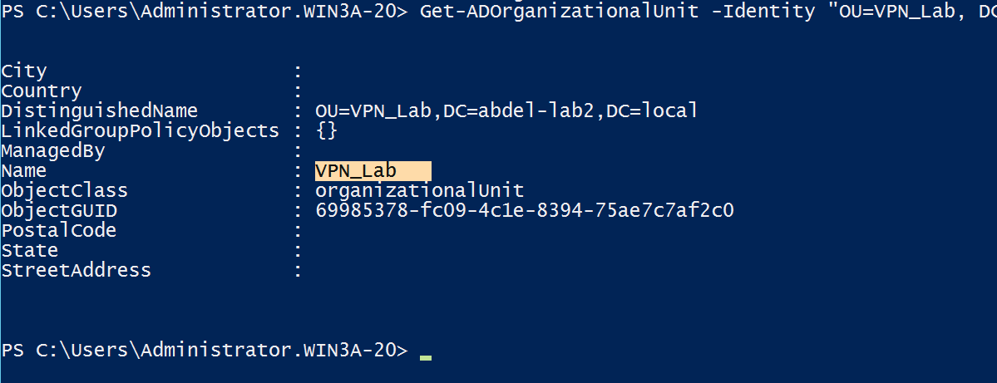

New-ADOrganizationalUnit -Name Users -path "OU=VPN_Lab,DC=abdel-lab2,DC=local" -Description "VPN users ou"

We will automate the creation of OUs using CSV file later in this course.

After creating the OUs lets create a new user in Users OU using powerShell.

New-ADuser –Name “Will Lanz” –SamAccountName “wlanz” –GivenName “Will” –Surname “Lanz” –DisplayName “Will Lanz” –UserPrincipalName [will@abdel-lab2.local](mailto:will@abdel-lab2.local)

-Path “OU=Users,OU=VPN_Lab,DC=abdel-lab2,DC=local” –Department “Sales”

To check the user properties use:

Get-ADUser wlanz

Note that the Enable option is set to false means that the user account is disabled.

First we need to set a password for the user in orthert o enable his account!

Set-ADAccountPassword-identity wlanz-Reset-NewPassword(ConvertTo-SecureString-AsPlainText”2015P@ssword” -Force)

Now we can enable the wlanz account using:

Enable-ADAccount -Identity wlanz

Now let’s go to windows 8 client and setup the VPN connection to the server

Open the network properties

Select set up new connection or network

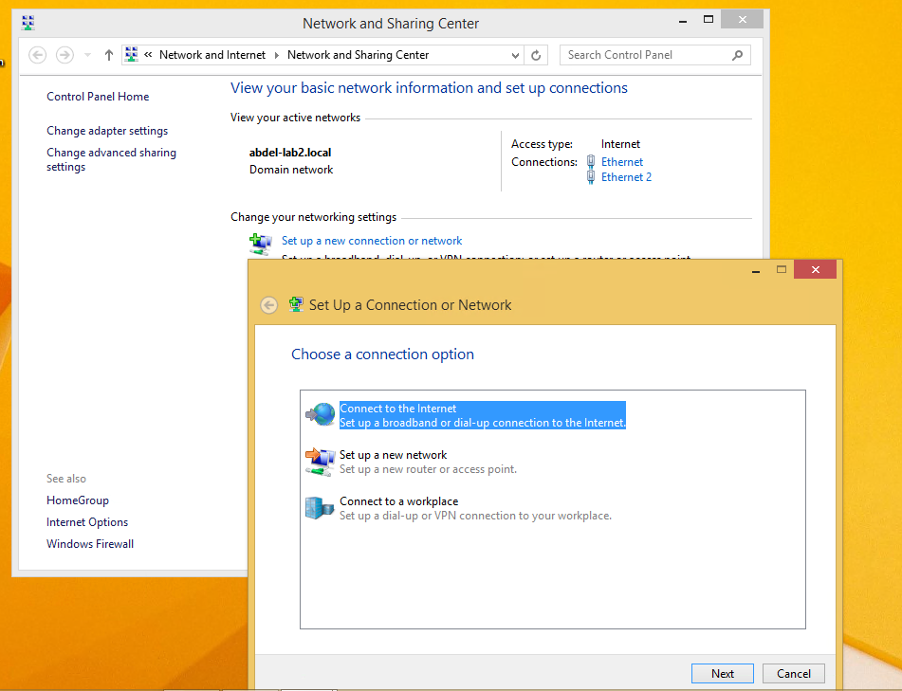

Then select Connect to workplace

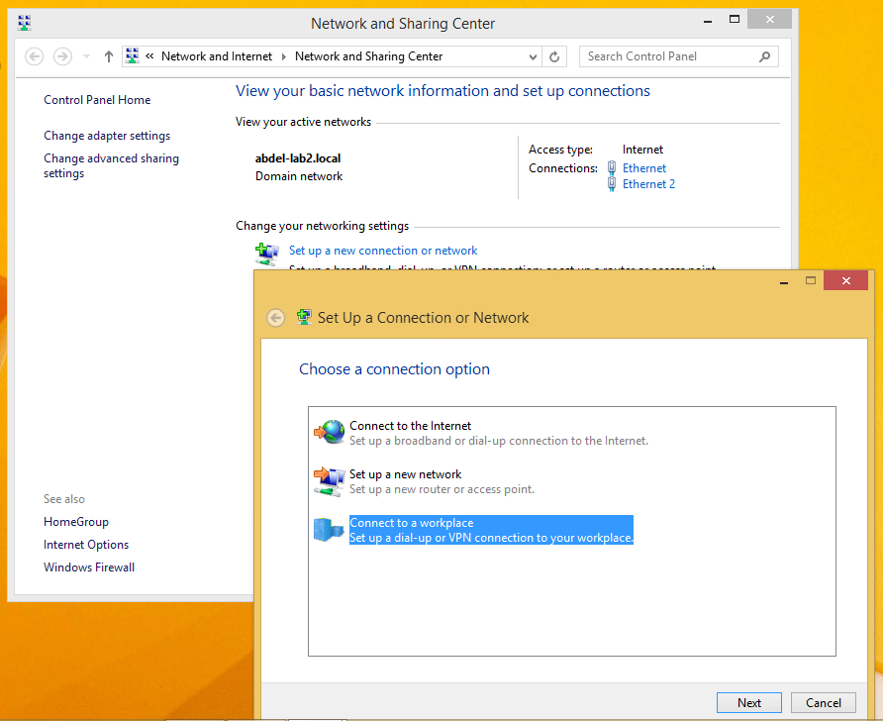

Click next, and select Use my Internet connection (VPN)

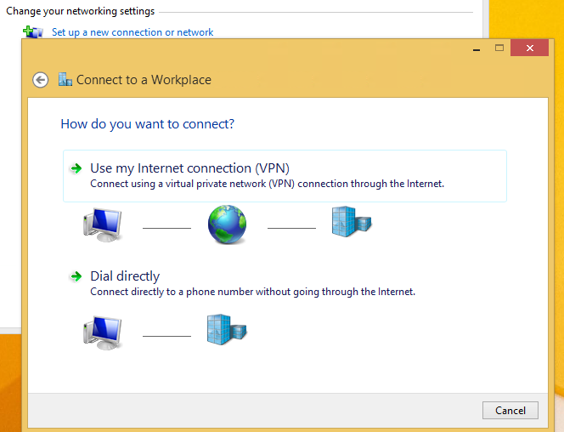

Type the IP address of the server and name the VPN connection as follows then click create:

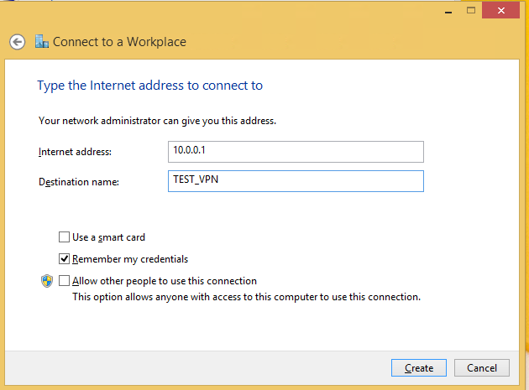

Try to connect, if you get the following error do not worry we will fix that!

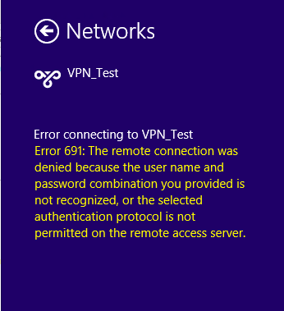

For troubleshooting this problem let’s check the event viewer on server.

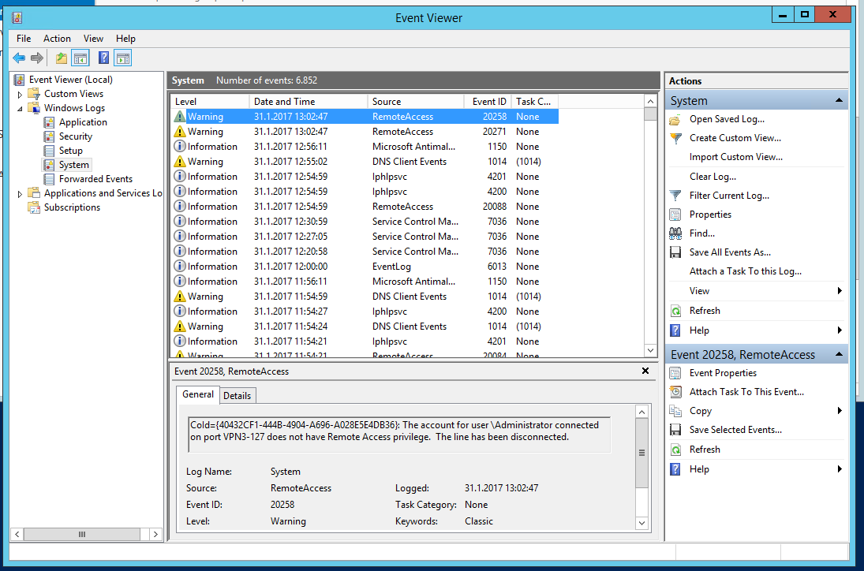

Check the warning message detail, its complaining about remote access user privilege

CoId={40432CF1-444B-4904-A696-A028E5E4DB36}: The account for user \Administrator connected on port VPN3-127 does not have Remote Access privilege. The line has been disconnected.

To fix this issue the user have to be enabled for Remote Access to connect to your VPN Server. On a standalone server this can be done in the Computer Management MMC, in a domain environment this can be done in the user properties of an Active Directory user.

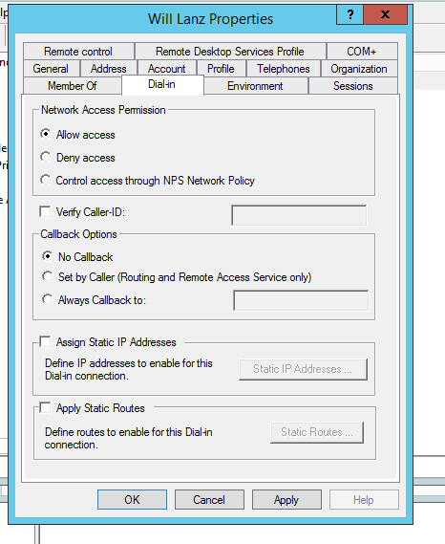

Now try again to connect, at this time the connection will ok via VPN